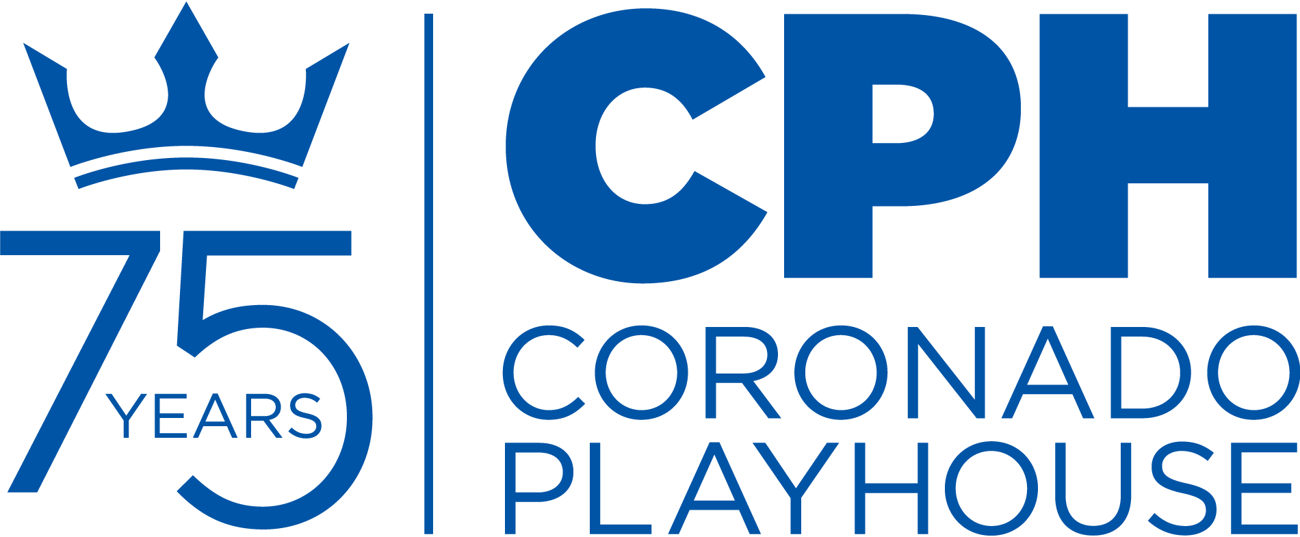
CONTACT:
Anthony Zelig
Production Manager
anthony@coronadoplayhouse.com
(917) 687-0699‬‬‬‬‬‬‬‬‬‬‬‬‬‬‬‬‬

FOR IMMEDIATE RELEASE:
June 7, 2021

Coronado Playhouse: A San Diego Tradition for 75 Years

CORONADO PLAYHOUSE PRESENTS THE COMEDY OF ERRORS
July 16 – August 8, 2021
CORONADO, CA – Coronado Playhouse continues its 2021 season with The Comedy of Errors, the FREE Classic, streaming online from Friday, July 16 through August 8.

The Comedy of Errors is the 25th annual FREE Classic production produced by the Playhouse. In 1997, under the direction of Keith A. Anderson, the Playhouse started an Annual Free Classic festival, offering Shakespeare and other classics at no cost to the public, due to a generous grant from the City of Coronado. This beloved tradition has been a Coronado Playhouse staple since it began. Anderson brought much talent, love and dedication to Coronado Playhouse, San Diego theatre and beyond. He directed scores of productions at CPH apart from beginning our FREE Classic series. Coronado Playhouse joined the local theatre community in mourning his passing earlier this year. The Playhouse is dedicating this year’s free classic in memory of Keith A. Anderson.

The Comedy of Errors​ is about the farcical misadventures of two sets of identical twins. Egeon, a Syracusan merchant, had twin sons both named Antipholus. At their birth, he bought another pair of newborn twins, both named Dromio, as their servants. In a shipwreck, Egeon lost his wife, one of his sons, and one of the Dromios.

Egeon's remaining son, Antipholus of Syracuse, and his servant, Dromio of Syracuse, later come to Ephesus, which—unknown to them—is the home of their lost twins. The new visitors are confused when local residents seem to know them. ​A series of wild mishaps based on ​mistaken identities​ lead to farcical and fantastic misunderstandings.

The Comedy of Errors​ is one of ​William Shakespeare's​ early plays. It is his shortest and one of his most ​farcical​ ​comedies​, with a major part of the humor coming from ​slapstick​, mistaken identity, ​puns​ and ​word play​.

Coronado Playhouse welcomes a new director, Dennis Floyd, to the project. Floyd is a long-time actor/director/scenic designer as well as a seasoned attorney with 37 years of experience. He has directed and designed several shows in his native Ohio, and most recently, within San Diego’s community theatre scene. Floyd did scenic design for Pickwick Players and Lamplighter’s Theatre and performed in Nuts at PowPAC and Treasure Island at Pickwick Players.

Floyd’s vision involves incorporating the pandemic of the time of Shakespeare into the production. These references will resonate with today’s audience. Floyd explains “the humor stems from the foibles of quarantining and distancing, adding to the frustrations experienced by the characters in the play. No humor is drawn from the disease itself.”

To adhere to current COVID-19 protocols, this show will be recorded on stage and streamed to patrons on-demand during the run of the show. Rehearsals and filming are also adhering to current protocols and restrictions.

Community Spotlight
Part of Coronado Playhouse’s mission is to give back to the community. For each show, Coronado Playhouse partners with a local non-profit to raise awareness and funds in support of their work. For the FREE Classic, the Playhouse is focusing on raising funds for itself, as tickets sales during the year only cover a portion of our annual expenses.
In order to maintain the high standard audiences have come to expect, CPH depends on donations to meet the bottom line. Please consider donating to Coronado Playhouse during this difficult time for the arts. To donate, please go to coronadoplayhouse.org/donate/.
Join the 75th Anniversary Campaign: 75 for 75.
In honor of the Playhouse’s 75th anniversary, they are inviting you to join the 75 for 75 campaign. For only $75, you will be helping Coronado Playhouse stay afloat in this pivotal year.
For only $75, your name will be added to a list of founders that intend to keep the Playhouse moving for the next 75 years. The goal is to raise a minimum of $7,500 for the year. With your support, we intend to continue to inspire audiences, young and old, to see the world in new ways. Together, we invest in fresh perspectives that inspire our community.
Help keep Coronado Playhouse a San Diego tradition for an additional 75 years and beyond. Visit coronadoplayhouse.org/75for75/ to join today.
About Coronado Playhouse
This is the fourth show in the CPH 2021 Season, which is the 75th anniversary for the Playhouse. CPH has prepared shows that will adhere to standards necessitated by COVID-19, while being comfortable for patrons and performers alike. The shows at the beginning of the year have been smaller in scale but had a big impact in terms of entertainment and significance. The shows later in the season will bring music and some of the larger scale productions patrons have come to expect from the historic institution.

The season includes six main shows, including a FREE classic production, and several concert and cabaret events. Other exciting programming includes readings and other 75th anniversary events.

Since 1946, the Playhouse has produced over 500 productions. Countless performers, designers and patrons have been a part of the Playhouse’s colorful 75-year history.

Coronado Playhouse is the longest continuously running community theatre in San Diego County, and, according to the LA Times, is the longest continuously running playhouse on the West Coast. The Playhouse still features cabaret-style seating, which has been its trademark throughout its history.

Single tickets are available for the remaining shows of the season. Please contact the box office.

###

Coronado Playhouse is a qualified 501(c)3 non-profit organization as
San Diego County’s longest continuously-run community theatre.

CONTACT:
Anthony Zelig
Production Manager
anthony@coronadoplayhouse.com
(917) 687-0699‬‬‬‬‬‬‬‬‬‬‬‬‬‬‬‬‬

ATTN: CALENDAR LISTINGS
FOR IMMEDIATE RELEASE:
June 7, 2021

WHO:
The Comedy of Errors
Written by William Shakespeare

Director: Dennis Floyd
Producer: Anthony Zelig

Featuring: Jesseal Amelia, Chris Braden, Annie Buchheit, Russell Clements, Jim Coulon, Julia Giolzetti, Steven Jensen, Jena Joyce, Eddy Lukovic, Sutheshna Mani, Robin Thompson, Tanner Vydos, Kristen Denine and Anthony Zelig

Design Team: Dennis Floyd (Director), Hunter Brown (Assistant Director, Fight Choreographer), Anthony Zelig (Producer, Production Manager), Ali Flores (Production Stage Manager), Stan Soth (Set Designer, Master Carpenter), Zephyr Landie (Lighting Designer & Operator), Marc Akiyama (Resident Sound Designer), Pam Stompoly (Costume Designer), Julia Giolzetti (Dramaturg), Pam Everett (Resident Properties Designer, FOH Manager), William Rickman (Co-Properties Designer), Duane McGregor (Set Painting), Barron Henzel (Marketing & Graphic Design), Amanda Everett (Box Office)

WHEN: July 16 – August 8, 2021
TIMES: This production is streaming on-demand. Patrons will be provided a link to watch a stream of the show during the dates of the run.

STREAM LINK: FREE
Streaming of this production is free, thanks to a grant from the City of Coronado. The link to stream the show will be shared on the Playhouse’s social media accounts as well as at coronadoplayhouse.org

WHERE: Streaming on-demand only.

MORE INFORMATION AVAILABLE EITHER ONLINE OR BY PHONE:
www.CoronadoPlayhouse.org | Box Office (619) 435-4856

CONTACTS:

Anthony Zelig  Production Manager  anthony@coronadoplayhouse.com  (917) 687-0699 ‬‬‬‬‬‬‬‬‬‬‬‬‬‬‬‬‬‬‬‬‬‬‬‬‬‬‬‬‬‬‬ | Coronado Playhouse  Box Office  boxoffice@coronadoplayhouse.com  (619) 435-4856

###

