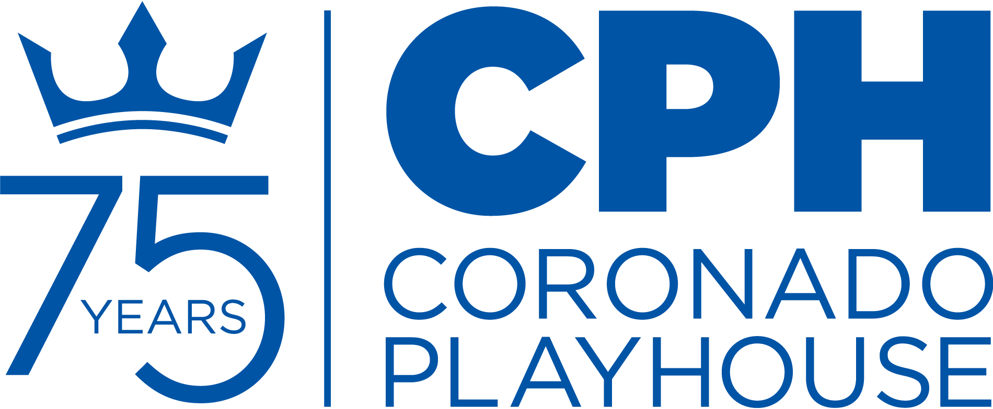
CONTACT:
Anthony Zelig
Production Manager
anthony@coronadoplayhouse.com
(917) 687-0699‬‬‬‬‬‬‬‬‬‬‬‬

FOR IMMEDIATE RELEASE:
April 22, 2021

Coronado Playhouse: A San Diego Tradition for 75 Years

CORONADO PLAYHOUSE PRESENTS CONSTELLATIONS
May 12 - May 30, 2021
CORONADO, CA – Coronado Playhouse proudly presents Constellations, the critically acclaimed play by Nick Payne, streaming on-demand from May 12 – May 30, 2021. Constellations received the UK’s Evening Standard Theatre Award for best play in 2012. The American premiere of Constellations opened on Broadway in January 2015 starring Academy Award nominee Jake Gyllenhaal and Ruth Wilson.

Nick Payne’s ​Constellations​ takes a chance encounter between two drifting souls, Marianne and Roland, and opens a door to the infinite possibilities of their relationship. ​Constellations​ is a spellbinding exploration at how the tiniest change in the details of our lives can dramatically alter the lives we live.

Suppose that life exists in a multiverse...a set of parallel existences that contain infinitely different outcomes. The possibilities in our lives are, quite literally, endless. Every possible event that could happen, does happen. And if Marianne and Roland meet...are drawn together in every version of existence...every possible happy ending and heartbreak​ that could befall them, will.
Coronado Playhouse has assembled an experienced creative team led by director Samuel Young to tell this poignant story. This marks Young’s third directing endeavor at Coronado Playhouse, after the 2019 production of The Winter’s Tale, by William Shakespeare and the 2020 production of Moon Over Buffalo, which was cancelled just before opening night due to COVID. Mr. Young previously performed on the Coronado Playhouse stage in Macbeth, Hamlet, King Charles III, and Much Ado About Nothing. As an actor and director, he has also been seen in numerous productions throughout the county.
This production is being featured during the San Diego Performing Arts League’s Theatre Month (formerly Theatre Week). The mission of San Diego Theatre Month is to highlight the variety and enhance the awareness of San Diego's diverse performing arts community.
To adhere to current COVID-19 protocols, this show will be recorded on stage and streamed to patrons on-demand during the run of the show. Rehearsals and filming are also adhering to current protocols and restrictions.
Please note: Constellations contains adult themes and strong language.
Community Spotlight – San Diego Brain Tumor Foundation
Community Theatre is made by, with and for the community in which it is performed. Coronado Playhouse is committed to pursuing community theatre in the truest sense of the words by giving back to the people of San Diego County and Coronado and using our public platform to raise awareness and help those in need.
During the run of Constellations, CPH is honored to be partnering with the San Diego Brain Tumor Foundation. The San Diego Brain Tumor Foundation serves the local community by providing funds to patients and their families who are coping with the daily stresses and difficulties of a brain tumor diagnosis. Through donations and fundraising efforts, the San Diego Brain Tumor Foundation can provide a variety of essential services to the local brain tumor community.

Please visit www.sdbtf.org to see how to volunteer or donate to this important cause.
About Coronado Playhouse
This is the third show in the CPH 2021 Season, which is the 75th anniversary for the Playhouse. CPH has prepared shows that will adhere to standards necessitated by COVID-19, while being comfortable for patrons and performers alike. The shows at the beginning of the year are smaller in scale but will have a big impact in terms of entertainment and significance. The shows later in the season, if permitted, will bring music and some of the larger scale productions patrons have come to expect from the historic institution.

The new season includes six main shows, including a FREE classic production, and several concert and cabaret events. Other exciting programming includes readings and other 75th anniversary events.

Since 1946, the Playhouse has produced over 500 productions. Countless performers, designers and patrons have been a part of the Playhouse’s colorful 75-year history.

Coronado Playhouse is the longest continuous running community theatre in San Diego County, and, according to the LA Times, is the longest continuous running playhouse on the West Coast. The Playhouse still features cabaret-style seating, which has been its trademark throughout its colorful history.

Season ticket renewals and new subscriptions are available now. Please contact the box office. Single tickets are also available.
###

Coronado Playhouse is a qualified 501(c)3 non-profit organization as
San Diego County’s longest continuously-run community theatre.

CONTACT:
Anthony Zelig
Production Manager
anthony@coronadoplayhouse.com
(917) 687-0699‬‬‬‬‬‬‬‬‬‬‬‬

ATTN: CALENDAR LISTINGS
FOR IMMEDIATE RELEASE:
April 22, 2021

WHO:
Constellations
Written by Nick Payne

Director: Samuel Young
Producers: Lenelle Wylie and Anthony Zelig

Featuring: Kylie Young, Heather Warren, Timothy Benson, Russell Clements

Design Team: Samuel Young (Director) Lenelle Wylie and Anthony Zelig (Co-Producers), Kathy Parks (Production Stage Manager), Samuel Young (Set Designer), Kristine Domingo (Costume Designer), Mickey Mounarath (Lighting Designer & Board Operator), Pam Everett (Resident Props Designer), Marc Akiyama (Resident Sound Designer), Marc Akiyama and Landon Akiyama (Film Production), Barron Henzel and Anthony Zelig (PR and Marketing), Barron Henzel (Graphic Design), Bayani Decastro Jr. (Production Photography), Pam Everett and Amanda Everett (Box Office), Anthony Zelig (Production Manager).

WHEN: May 12 – May 30, 2021
TIMES: This production is streaming on-demand. Ticket holders will be provided a unique link to watch a stream of the show one time, during the dates of the run.

TICKETS: $25.00 per household
As tickets are per household and not per person, there are no senior or military discounts for this show.

WHERE: Streaming on-demand only.

TICKETS AVAILABLE EITHER ONLINE OR BY PHONE:
www.CoronadoPlayhouse.org | Box Office (619) 435-4856

CONTACTS:

Anthony Zelig  Production Manager  anthony@coronadoplayhouse.com  (917) 687-0699 ‬‬‬‬‬‬‬‬‬‬‬‬‬‬‬‬‬‬‬‬‬‬‬‬‬‬ | Coronado Playhouse  Box Office  boxoffice@coronadoplayhouse.com  (619) 435-4856

Constellations is presented by special arrangement with Dramatists Play Service, Inc., New York.

###

