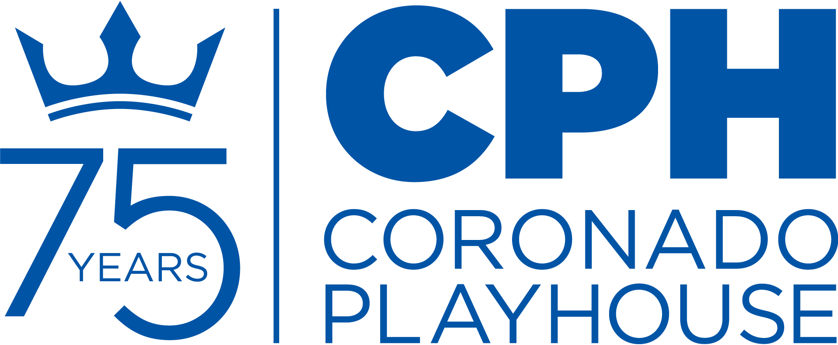
CONTACT:
Anthony Zelig
Production Manager
anthony@coronadoplayhouse.com
(917) 687-0699‬‬‬‬‬‬‬

FOR IMMEDIATE RELEASE:
February 16, 2020

Coronado Playhouse: A San Diego Tradition for 75 Years

CORONADO PLAYHOUSE PRESENTS HARLEM DUET
March 19-April 18, 2021

CORONADO, CA – Coronado Playhouse proudly presents Harlem Duet, the critically acclaimed play by Djanet Sears, streaming on-demand from March 19-April 18. Harlem Duet received Canada's highest literary honor for dramatic writing, the Governor General's Literary Award, in 1998. That year it also received the Floyd S. Chalmers Canadian Play Award.
In what could be a prelude to Shakespeare’s Othello, Djanet Sears's ​Harlem Duet recounts the story of Othello and his first wife, Billie (before Desdemona). Their history is told through the lives of three couples during eras of special significance in the Black American Experience. This is a weighty play that leaves the viewer with no easy answers.
Set in contemporary Harlem at the corner of Martin Luther King and Malcolm X Boulevards, the tale tows the line of racial identity, sexual politics, and mental illness in the Black community. Sears's script diffuses the action through three timelines: the 1860s, 1928 and the present.
Director Kandace Crystal was introduced to this show 15 years ago and fell in love with it. “At that time, I didn't see many leads who looked like me” said Crystal, who is a first-time director at CPH. “Having an all-Black cast that wasn't an August Wilson play was refreshing and necessary.” Harlem Duet's themes transcend race. “It's a commentary on humanity. Every single person has experienced heartbreak in some form or another as well as loss and grief. We also see an exploration of declining mental health, Black Love, and the proximity to Whiteness. The Shakespearean tie-in and the non-chronological structure present a unique directorial challenge and take on an ancient text. A remix of sorts.”
Crystal’s vision was simple–to follow the playwright's model. “How would Othello look through the eyes of a Black Woman? Moving the narrative from the white, male gaze allows us to, in essence, take back our story and tell them through our own lenses.” This allows Crystal a unique opportunity to explore relationships–romantic or platonic–and how they affect interactions with others in life.
Director Kandace Crystal (@KandaceCrystal) is Artistic Director of American History Theatre and Associate Artistic Director of Trinity Theatre Company. Crystal implemented an online discussion series examining historical American events on the mental health of marginalized communities. With Trinity, she has built a partnership with Kitabu Club Adventures for our youngest audiences to see themselves in the books they read. Additionally, in response to the disproportionate murder of black and brown people at the hands of police, Kandace developed a podcast/oral documentary with Cloudcast Media entitled 8:46-The Catalyst for Change as a means of documenting feelings and responses to the current epidemic. Her directorial credits include: The Mountaintop (AHT/TRTC), Donna Orbits the Moon (Scripps Ranch Theatre), and Clybourne Park (Trinity Theatre Company).
To adhere to current COVID-19 protocols, this show will be recorded on stage and streamed to patrons on-demand during the run of the show. Rehearsals and filming are also adhering to current protocols and restrictions.
Please note, Harlem Duet contains adult language and themes.
Community Partner – Rachel’s Women’s Center
Community Theatre is made by, with and for the community in which it is performed. Coronado Playhouse is committed to pursuing community theatre in the truest sense of the words by giving back to the people of San Diego County and Coronado and using our public platform to raise awareness and help those in need.
During the run of Harlem Duet, CPH is honored to be partnering with Rachel’s Women’s Center. Rachel’s Women’s Center provides a safe, supportive, sober environment and opportunities for women with few or no resources to gather, begin, and continue self-help efforts.
Please visit https://ccdsd.org/homeless-womens-services/ to see how to volunteer or donate to this important cause.
Special Events
Two community Zoom talkbacks
Join the San Diego Black Artist Collective, CPH and the Harlem Duet team in discussing a range of topics that relate to the show and the broader Black Experience. Details will be announced.

About Coronado Playhouse
This is the second show in the CPH 2021 Season, which is the 75th anniversary for the Playhouse. CPH has prepared shows that will adhere to standards necessitated by COVID-19, while being comfortable for patrons and performers alike. The shows at the beginning of the year are smaller in scale but will have a big impact in terms of entertainment and significance. The shows later in the season, if permitted, will bring music and some of the larger scale productions patrons have come to expect from the historic institution.

The new season includes six main shows, including a FREE classic production, and several concert and cabaret events. Other exciting programming includes readings and other 75th anniversary events.

Since 1946, the Playhouse has produced over 500 productions. Countless performers, designers and patrons have been a part of the Playhouse’s colorful 75-year history.

Coronado Playhouse is the longest continuous running community theatre in San Diego County, and, according to the LA Times, is the longest continuous running playhouse on the West Coast. The Playhouse still features cabaret-style seating, which has been its trademark throughout its colorful history.

Season ticket renewals and new subscriptions are available now. Please contact the box office. Single tickets are also available.

###

Coronado Playhouse is a qualified 501(c)3 non-profit organization as
San Diego County’s longest continuously-run community theatre.

CONTACT:
Anthony Zelig
Production Manager
anthony@coronadoplayhouse.com
(917) 687-0699‬‬‬‬‬‬‬

ATTN: CALENDAR LISTINGS
FOR IMMEDIATE RELEASE:
February 17, 2021

WHO:
Harlem Duet
Written by Djanet Sears

Director: Kandace Crystal
Producer: Anthony Zelig

Featuring: Heather Barton Tjalma, Malachi Beasley, Danielle Bunch, Carla BaNu Dejesus, Ahmed Kenyatta Dents, Andrea Acuna.

Design Team: Kandace Crystal (Director), Anthony Zelig (Producer), Beonica Bullard (Production Stage Manager, Costume Designer), Kimberly King (Dramaturg), Dennis Floyd (Set Designer), Kevin “Blax” Burroughs (Lighting Designer & Board Operator). Marc Akiyama (Sound Designer/Film Production), Kathy Parks (Prop Designer), Natalie Griffith Robichaux (Intimacy Choreographer), Landon Akiyama (Film Production), Stan Soth (Master Carpenter), Duane McGregor (Set Dressing/Painting).

WHEN: March 19-April 18, 2021
TIMES: This production is streaming on-demand. Ticket holders will be provided a unique link to watch a stream of the show one time, during the dates of the run.

TICKETS: $25.00 per household
As tickets are per household and not per person, there are no senior or military discounts for this show. However, discount arrangements are being permitted to those in need. Please inquire with the box office.

WHERE: Streaming on-demand only.

TICKETS AVAILABLE EITHER ONLINE OR BY PHONE:
www.CoronadoPlayhouse.org | Box Office (619) 435-4856

CONTACTS:

Anthony Zelig  Production Manager  anthony@coronadoplayhouse.com  (917) 687-0699 ‬‬‬‬‬‬‬‬‬‬‬‬‬‬‬‬‬‬‬‬‬ | Coronado Playhouse  Box Office  boxoffice@coronadoplayhouse.com  (619) 435-4856

Harlem Duet premiered on April 24, 1997, as a
Nightwood Theatre production, at the Tarragon Extra Space, Toronto, Canada
Harlem Duet is staged by arrangement with Pam Winter, GGA, www.ggacency.ca
###

